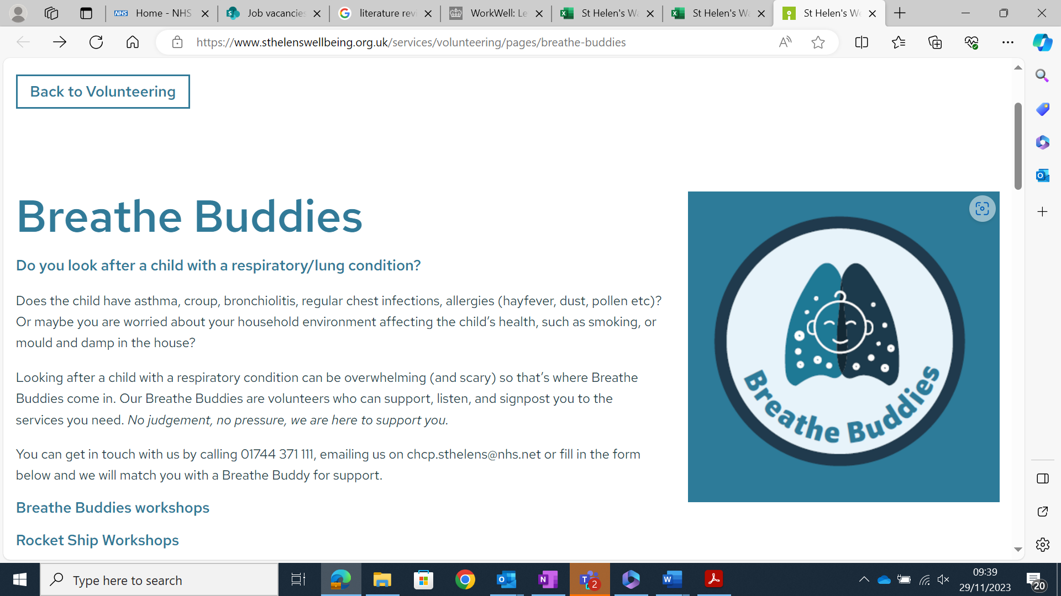

Breathe Buddies

Do you look after a child with a respiratory/lung condition?
Does the child have asthma, croup, bronchiolitis, regular chest infections, allergies (hayfever, dust, pollen etc)? Or maybe you are worried about your household environment affecting the child’s health, such as smoking, or mould and damp in the house?
Looking after a child with a respiratory condition can be overwhelming (and scary) so that’s where Breathe Buddies come in. Our Breathe Buddies are volunteers who can support, listen, and signpost you to the services you need. No judgement, no pressure, we are here to support you.
You can get in touch with us by calling 01744 371 111, emailing us on chcp.sthelens@nhs.net or fill in the form below and we will match you with a Breathe Buddy for support.
Check the website for details of workshops:
https://www.sthelenswellbeing.org.uk/services/volunteering/pages/breathe-buddies

